
Material Selection & Suitability
Using natural stone correctly -
indoors, outdoors, wet areas and in operation
Most wrong decisions in natural stone are not caused by lack of knowledge, but by false assumptions:
“It will be fine.”
“We’ve always done it this way.” “It looks perfect.”

Natural stone is honest.
It does not respond to trends – it responds to use.
Not to intention, but to exposure.
Not to design wishes, but to daily reality.

This guide helps to approach material selection realistically. Not emotionally. Not dogmatically.
But in the context of location, use and operation.
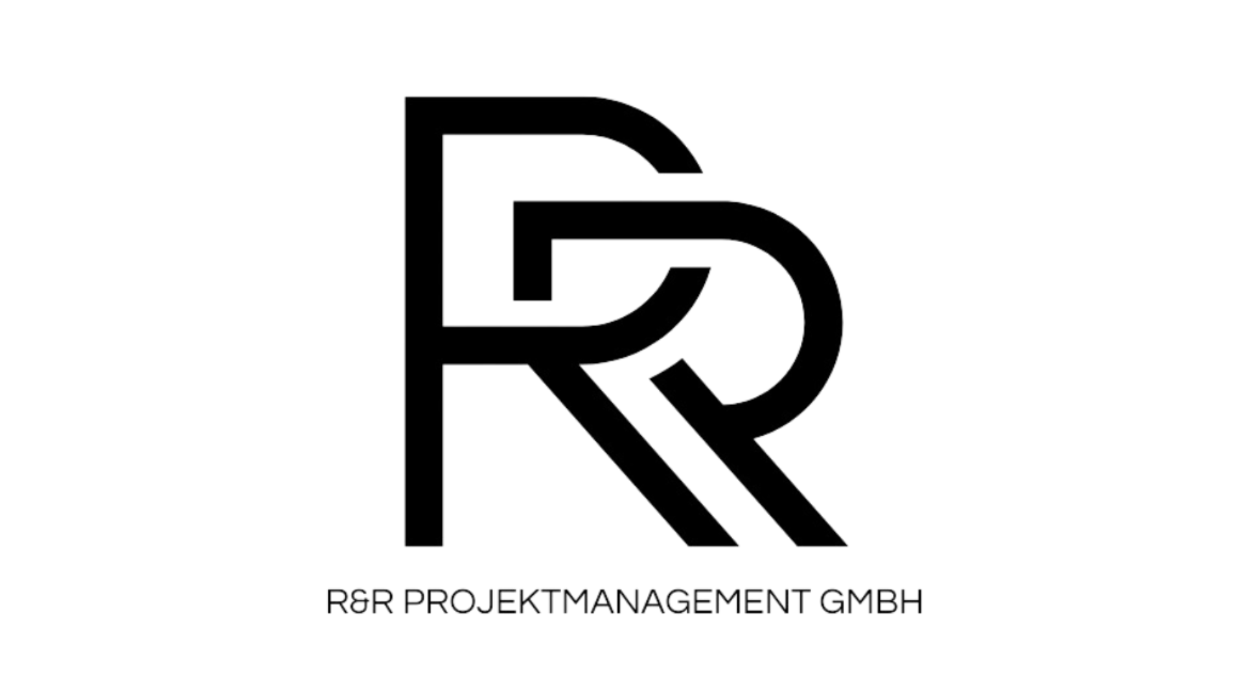

Purpose of this guide
This PDF supports you in:

- selecting natural stone based on suitability, not appearance
- identifying risks early
- avoiding wrong decisions before ordering or installation

What this guide deliberately is not

- a complete material science handbook
- a substitute for professional planning or expert reports
- a recommendation of specific stone types

Good decisions are not made by more information, but by asking the right questions at the right time.

Step 1: Clearly deﬁne the area of use
Before discussing material, the area of use must be clear.

- Interior – private / office
- Interior – public / high traffic
- Exterior – covered
- Exterior – fully exposed
- Wet areas (bathrooms, spa, pool surroundings)
- Special use (hotel, gastronomy, retail, office)

Note:
A natural stone may perform perfectly in one area and cause long-term issues in another.

Assess each point realistically – not optimistically.
- Moisture & water

  - permanent
  - regular
  - occasional
  - negligible
- Mechanical load
  - point loads (furniture, edges, heels)
  - surface load (foot traffic, trolleys, cleaning machines)
- Chemical exposure

  - cleaning agents
  - food, acids, fats
  - de-icing salts / environmental exposure
- Visual expectation
  - as uniform as possible
  - naturally varied
  - patina explicitly desired
- Operation & maintenance

  - professional facility management
  - limited maintenance
  - private use without training

Key insight:
The higher the use intensity, the more honest the material choice must be.

“The stone is hard – it can handle it.”
→ Hardness alone does not define operational suitability.

“It’s a natural product – that’s normal.”
→ Yes. But only if this was consciously accepted in advance.

“With the right maintenance, everything works.”
→ Maintenance can support – it cannot fix a wrong material choice.

“We used this stone elsewhere as well.”
→ Same stone ≠ same use ≠ same conditions.

Decision support: the trafﬁc-light logic
Evaluate the planned material objectively:

 Suitable
use, load and operation are aligned

 Conditionally suitable

only with defined measures & expectation management

 Critical
high risk of damage, complaints or additional costs
  - Use clearly defined
  - Operation realistically assessed
  - Maintenance effort accepted
  - Decision documented

Good material selection is invisible.
It simply works – quietly and reliably, for years.

This guide does not replace professional planning.
But it protects against decisions that become expensive later.

Further insights, case examples and in-depth knowledge can be found in our additional guides and expert formats.

R&R Projektmanagement GmbH - www.raddato.com - +49 (0) 6103 702600



PDF 01 EN I 5 pages I Date of revison January 5, 2026

