
Maintenance & Care Logic
Preserving natural stone long term - for facility management & operators

Natural stone does not age randomly.
It reacts to what happens to it every day - cleaning routines, usage patterns, neglect.
Many damages are not the result of poor planning,
but of missing maintenance logic once the building is in operation.

This guide creates clarity between material, use and maintenance - so natural stone is not only handed over in perfect condition,

but preserved sustainably over time.

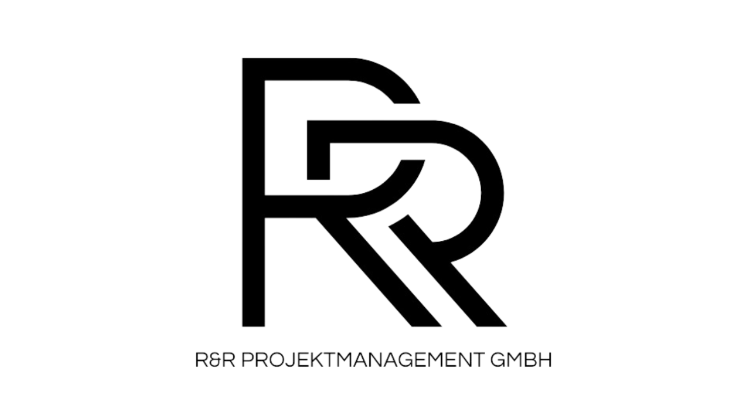

Purpose & Scope

Purpose of this guide
This guide supports you in:

- assessing maintenance and care requirements realistically
- clearly defining responsibilities in daily operation
- protecting substance, appearance and functionality long term

What this guide deliberately is not

- a cleaning manual for specific products
- a list of chemical recipes
- a substitute for object-specific maintenance plans

If maintenance is not planned, repair is already scheduled.

Step 1: Assess use & operation honestly
Maintenance does not start with cleaning agents, but with honesty about usage.

- private use
- public use
- high foot traffic
- changing users
- professional facility management in place

Key questions:

- How often is cleaning carried out?
- By whom?

Step 2: Differentiating types of care
Not every measure is maintenance and not every cleaning process is caring.

Routine care
- regular cleaning cycles
- material-compatible agents
- trained personnel

Periodic care
- intensive cleaning
- re-impregnation
- surface refreshment

Maintenance & inspection
- condition checks
- early damage detection
- preventive measures

Key distinction: Pflege erhält Optik. Wartung erhält Substanz.

Typical care mistakes from practice
“More chemistry helps more.”
→ often leads to surface damage.

One cleaning concept for all surfaces
→ ignores material differences.

Maintenance only when damage is visible
→ reactive instead of preventive.

Missing documentation
→ no traceability, no security.

Operational decision logic
Assess maintenance & care objectively:

Maintenance concept defined
→ measures, intervals and responsibilities clarified

Partially regulated
→ risk of visual or functional impairment

Not regulated
→ accelerated wear and rising follow-up costs

- usage considered
- staff trained
- maintenance intervals defined
- measures documented

Value preservation (investor perspective)
Natural stone is an asset. Its condition influences:

- perception & image
- operating costs
- renovation cycles
- resale value

Key thought:
Good maintenance is invisible. Poor maintenance never is.

.

Closing
Maintenance is not an add-on.
It is part of the planning – only time-shifted.

This guide helps to view care and maintenance not as a reaction,
but as a strategic component of the project.

Further insights, case examples and in-depth knowledge can be found in our additional guides and expert formats.n.

R&R Projektmanagement GmbH - www.raddato.com - +49 (0) 6103 702600

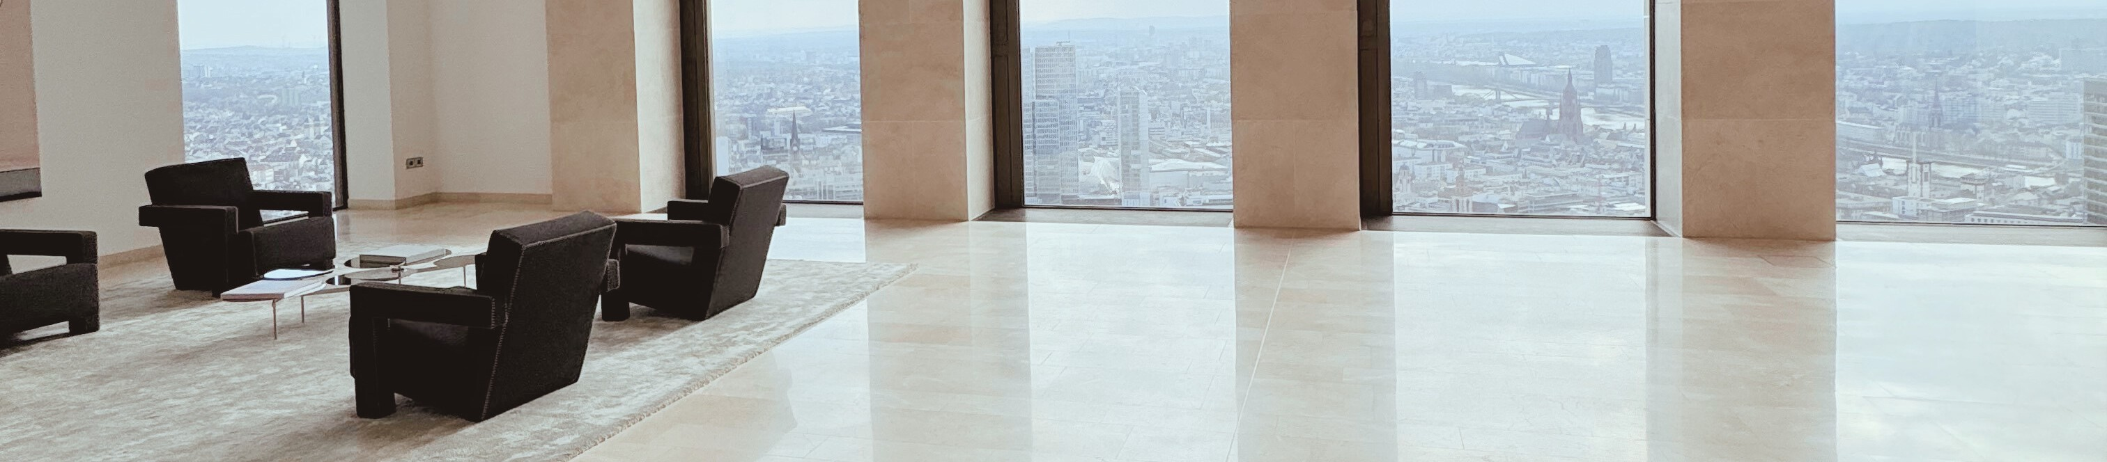

PDF 03 EN I 5 pages I Date of revison January 5, 2026

